**SQL ASSIGNMENT-4**

**QUESTIONS:**

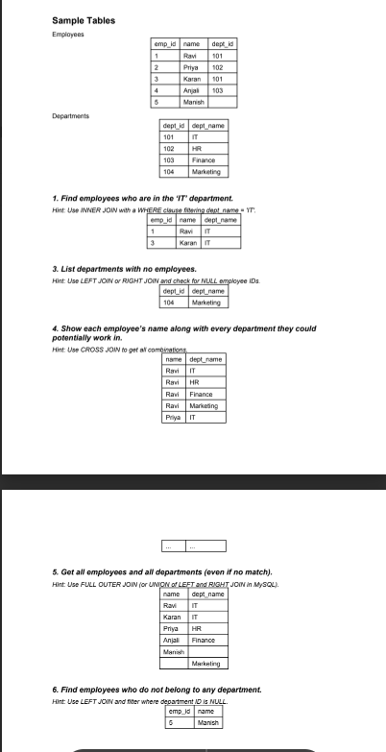

**ANSWER:**

**USE new;**

**create table Employees1(emp_id int,name varchar(20),dept_id int);**

**insert into Employees1 values(1,"Ravi",101),(2,"Priya",102),(3,"Karan",101),(4,"Anjali",103);**

**insert into Employees1 (emp_id,name)values(5,"Manish");**

**select*from Employees1;**

**create table Departments(dept_id int, dept_name varchar(20));**

**insert into Departments values(101,"IT"),(102,"HR"),(103,"Finance"),(104,"Marketing");**

**select*from Departments;**

**select emp_id,name,dept_name from Employees1 e inner join Departments d on e.dept_id = d.dept_id where d.dept_name = 'IT';**

**select emp_id,name from Employees1 e left join Departments d on e.dept_id = d.dept_id where e.dept_id is null;**

**select e.name,d.dept_name from Employees1 e cross join Departments d;**

**select e.name,d.dept_name from Employees1 e left join Departments d on e.dept_id = d.dept_id**

**union**

**select e.name,d.dept_name from Employees1 e right join Departments d on e.dept_id = d.dept_id;**

**select emp_id,name from Employees1 e left join Departments d on e.dept_id = d.dept_id where e.dept_id is null;**

